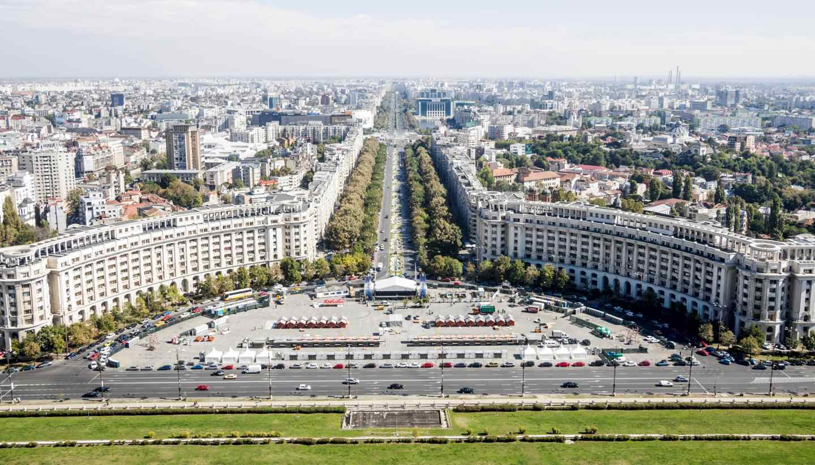

*Tulay Caglayan – October 2019*

|  |
| --- |
|  |
| The Battle of Neighborhoods |
|  |
| Opening new Turkish Restaurant in Bucharest, Romania |
| *IBM Data Science Professional Certificate – Capstone Project* |

The Battle of Neighborhoods

Opening new Turkish Restaurant in Bucharest, Romania

# 1. Introduction

## 1.1 Background

Bucharest is the capital and largest city of Romania, as well as its cultural, industrial, and financial center. It is located in the southeast of the country, at coordinates: 44°25′57″N 26°06′14″E, less than 60 km (37.3 mi) north of the Danube River and the Bulgarian border. [1]

Bucharest is the center of the Romanian economy and industry, accounting for around 24% (2017) of the country's GDP and about one-quarter of its industrial production, while being inhabited by 9% of the country's population. Bucharest has **1.883.425**(2018) populations and consists of **6 sectors**. Neighborhoods and populations in sectors are as below (2016): [1]

* **Sector 1** *(population 227,717):* Dorobanți, Băneasa, Aviației, Pipera, Primăverii, Dămăroaia, Grivița
* **Sector 2** *(population 357,338):* Pantelimon, Colentina, Iancului, Tei, Floreasca, Moșilor, Obor, Fundeni,
* **Sector 3** *(population 399,231):* Vitan, Dudești, Titan, Centrul Civic, Dristor, Lipscani
* **Sector 4** *(population 300,331):* Berceni, Olteniței, Progresul, Văcărești, Tineretului
* **Sector 5** *(population 288,690):* Rahova, Ferentari, Giurgiului, Cotroceni, 13 Septembrie, Dealul Spirii
* **Sector 6** *(population 371,060):* Giulești, Crângași, Drumul Taberei, Militari, Grozăvești(Regie), Ghencea

As stated by the Mercer international surveys for **quality of life** in **231** cities around the world, Bucharest occupied the **109th** place in 2019. Bucharest, at number 109, ranks low in the European list but better than other European cities such as Sofia (116th) and Belgrade (139th). [2]

Many neighborhoods, particularly in the southern part of the city, lack sufficient green space, are formed of cramped high density block of flats. This may affect people’s life as well.

## 1.2. Problem

In this project, I will investigate that if there is any good location in Bucharest for opening Turkish restaurant and it really values to open one.

## 1.3. Interest

Anyone wants to open a new venue in any geographic location may be interested in this project by modifying search criteria.

# 2. Data

## 2.1 Data sources

To consider the problem we can list the data as below:

* I got the sector data of Bucharest from Wikipedia [1]
* I got the neighborhood data of Bucharest from Wikipedia [3]
* I used python geocoder library to get geographical coordinates of neighborhoods[4]
* I used **Foursquare API** **venues explore** method to get the venues of given neighborhoods of Bucharest [5].
* I used **Foursquare API venues method** to get ranks and likes of restaurants by given venue id [5].

## 2.2 Feature Selection and Data Usage

* I will use neighborhood location values to analyze Bucharest geographical structure. I will use folium library of python to draw maps by using given latitude and longitudes of neighborhoods. Selected features will be as below

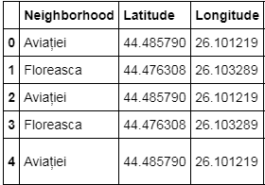

* I will use populations of neighborhoods who has big population may need a new restaurant.

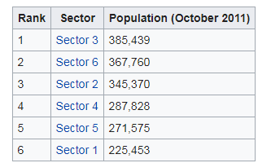 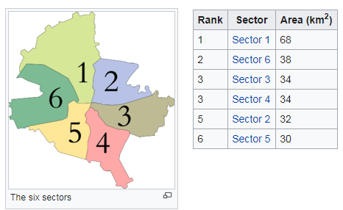

* I will also classify neighborhoods by using venues distribution and counts. In this way, I will find similarities of neighborhoods which will help me to choose location for opening a new restaurant. Similar structured neighborhoods may handle same type of venue.

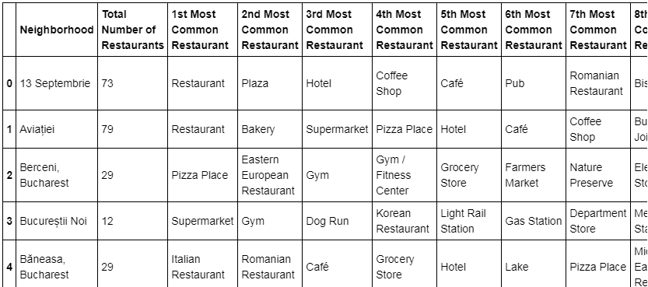

* I will use venue list category to find distribution of restaurants and Turkish restaurants in neighborhoods.

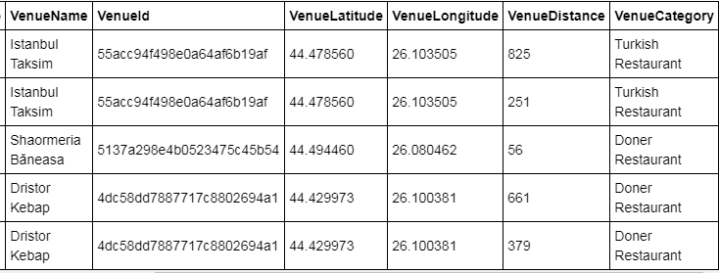

* I will use also ratings and likes of restaurants in the areas. It may help me to find location with bad rating restaurants which may need a new restaurant.

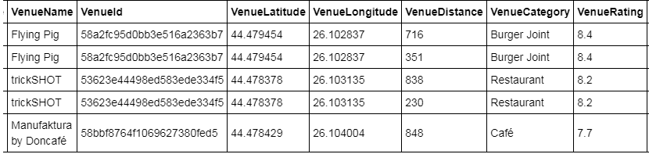

## References:

* [1] [Bucharest — Wikipedia](https://en.wikipedia.org/wiki/Bucharest)
* [2] [Mercer’s Quality of Life Survey](https://www.romania-insider.com/mercer-bucharest-quality-living-2019)
* [3] [Category:Districts of Bucharest](https://en.wikipedia.org/wiki/Category:Districts%20of%20Bucharest)
* [4] [Python Geocoder Library](https://geocoder.readthedocs.io/)
* [5] [Foursquare API](https://developer.foursquare.com/)

# 3. Methodology

* I used GitHub repository for code versioning.
* The Bucharest data is available with the neighborhood name in wikipedia. Location information (latitude and longitude) of neighborhoods are taken from geocoder library.
* I took neighborhood from wikipedia and put blue dots on Bucharest map to see centers of neighborhoods. There are **40** neighborhoods in Bucharest

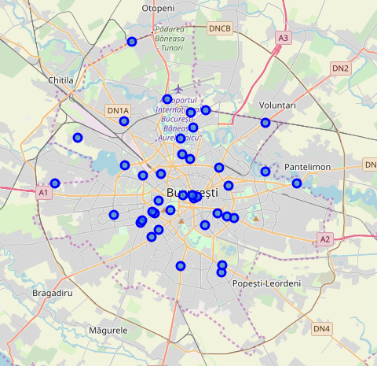

* I also got sector names of neighborhoods and populations of sectors. There are 6 sectors in Bucharest. I also merged Sector and Neighborhood data to see in which sector neighborhood places.

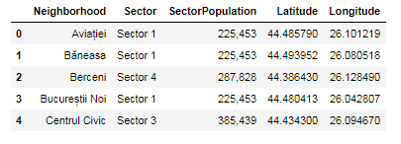

By using Foursquare API I got venues **1 km** around center of each neighborhood with limit **100 venue**. I merged data with Neighborhood data. Head of the merged data is as below

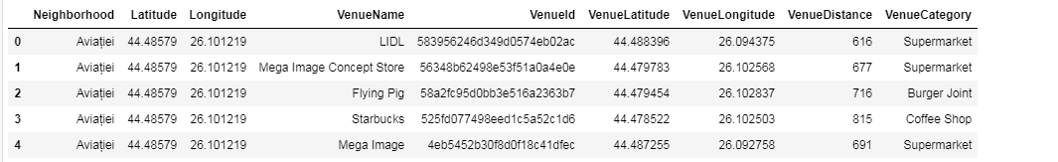

* There are 225 unique venue categories in Bucharest and top 10 venue counts is as below

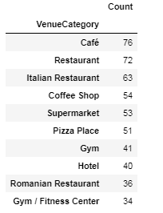

* I filtered All restaurants and Turkish restaurant. We can see from histogram of restaurants, **19** neighborhoods has **not** any Turkish restaurant

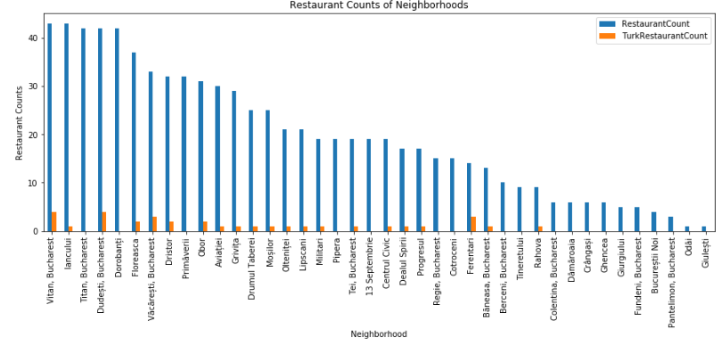

* I used foursquare to get restaurant ratings by using venuid and merged with venue data

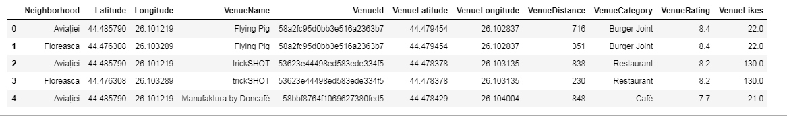

* I drawed heatmap for counts of restaurants in neighborhoods by using Folium library. On heatmap, I also drawed 4 few circles indicating distance of 2km, 4km, 6km and 10km from Bucharest center.

I superimposed Turkish restaurants with **red** markers and **blue** markers as Turkish restaurants with rating less than 7 restaurants on first map.I superimposed neighborhoods **without any Turkish** restaurant with **cyan** markers in second heatmap

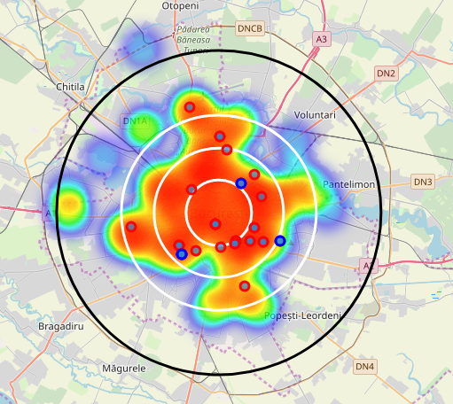 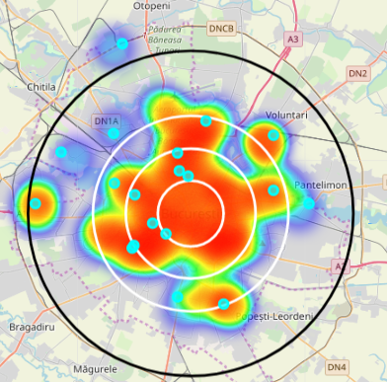

* I used Agglomerative Clustering to cluster neighborhoods according to count of venue categories in each neighborhood. According to the below graph, I decided to separate our neighborhoods into 6 clusters (cut at distance of 20, horizontal black line). 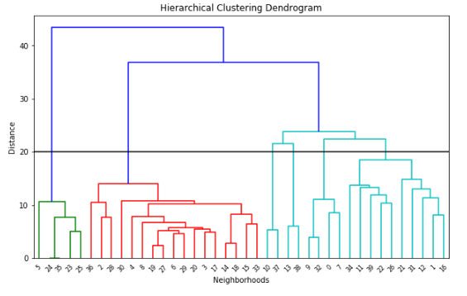

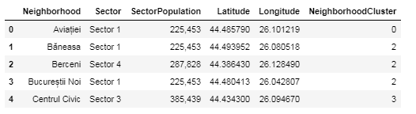

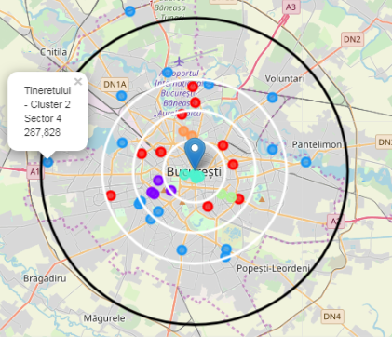 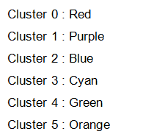

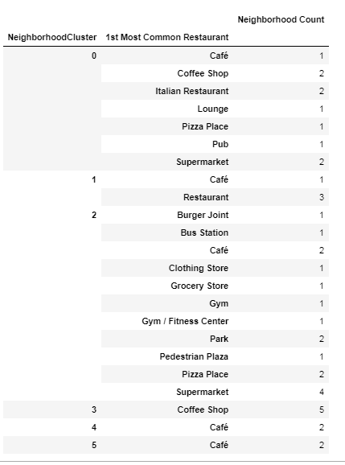 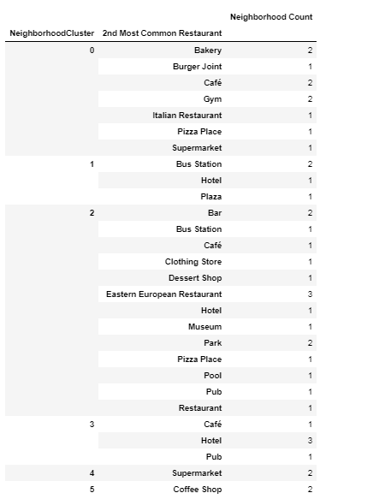

Cluster 0 : Italian Restaurant , Pizza, Café

Cluster 1 : Restaurant , Bar

Cluster 2 : Park , Plaza, Clothing stores , Museum, Gym

Cluster 3 : Coffee Shop, Hotel, Pub

Cluster 4 : Café, Suprmarket

Cluster 5 : Café

# 4. Results

I investigated that Turkish restaurant counts in Bucharest is **4.18%**

* Total number of restaurants: 502
* Total number of Turkish restaurants: 21

From bar chart, we can see;

* Vitan is the neighborhood having most restaurants
* Dorobanti is has lots of restaurants , but no Turkish restaurant
* Odai and Gluesti are neighborhoods having least number of restaurants
* 19 neighborhoods do not have any Turkish restaurant. We can choose one of these to open restaurant.

From heat maps, we can see that there are

* Too many restaurants in 4 km to the center
* Enough restaurants between 4-6 km to the center
* There are **not many**restaurants after **6 km to center**
* Turkish restaurants are located in South, North , East, between 2-4 Km distance around center
* There are **not** Turkish Restaurants in West and North West part
* Some Turkish restaurants gets bad points. That means people does not prefer these restaurant too much and any turkish restaurant may be opened around

# 5. Discussion

Cluster 2 suffers from restaurant. Especially there is no Turkish restaurant in west part of Cluster 2 . We can think about Cluster 2 , West part

Cluster 0 especially likes Italian tastes , may be these neighborhoods will not like Turkish tastes . We can only think about 1 location may be.

Cluster 1, 2, 3 are centers full of restaurants as we saw in the heat map. . So we cannot think about these areas

# 6. Conclusion

I have chosen 4 locations for opening Turk restaurant. Below are locations of neighborhoods. I hope this work will help somebody who wants to open a new Turkish restaurant in Bucharest.

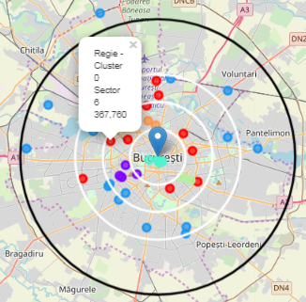 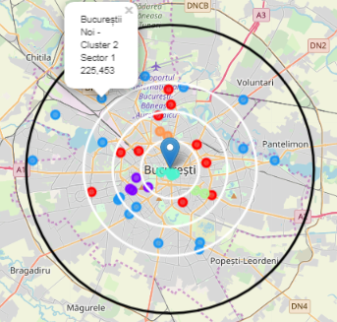

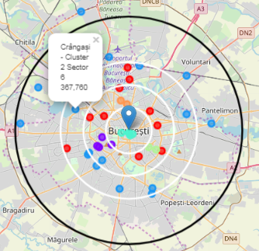 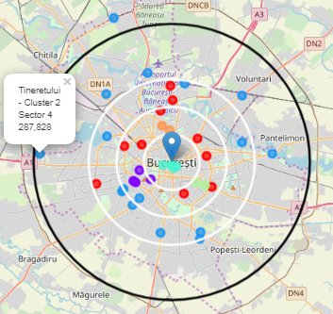

* Neighborhood : Regie - Cluster 0, Sector 6, 367.760

I choosed Regie , since west part of Bucharest has not Turkish restaurant and Regie is close to center . Regie is red cluster which is same with the other 2 red markers having Turk restaurant. Red clusters populations may like Turkish food.

* Neighborhood : Bucureștii Noi , Cluster 2, Sector 1 , Population : 225453

I choosed Bucharest-noi , since west part of Bucharest has not Turkish restaurant and even not too much restaurant after 6 km distance to center . One restaurant will be good for this area.

* Neighborhood : Crângași , Cluster 2, Sector 6 , Population : 367760

I choosed Crangasi , since Crangasi and west part of Bucharest has not Turkish restaurant and from bar chart we can see that this neighborhood has not too much restaurant. Also this neighborhood is in Sector 6 and this sector has biggest population which will handle one more restaurant

* Neighborhood : Tineretului , Cluster 2, Sector 4 , Population : 287828

I choosed Tineretului , since Tineretului has not Turkish restaurant and from bar chart we can see that this neighborhood has not too much restaurant.